**Comparison of Model building:**

|  |  |  |
| --- | --- | --- |
| **Metrics** | **LSTM** | **BERT** |
| Training loss | 0.1872 | 0.33923 |
| Validation loss | 0.6766 | 0.4932 |

LSTM model is having high validation loss than training loss, LSTM model has overfitting.

BERT model has the less difference between validation and training loss.

**Comparing based on class prediction:**

**LSTM: BERT**

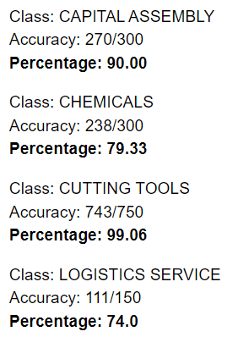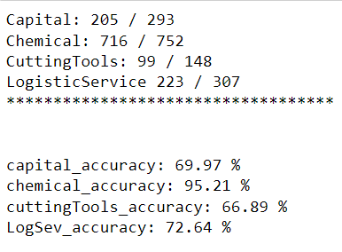

Based on class prediction also I will select BERT model. But BERT model will take more time to take the training the data set. But it can be save and used for future unseen prediction.

**Note:** I have saved model ephos in “data_volume” folder